**DAILY ONLINE ACTIVITIES SUMMARY**

|  |  |  |  |  |  |  |  |
| --- | --- | --- | --- | --- | --- | --- | --- |
| **Date:** | **01/06/2020** | | | | **Name:** | **AMRUTHA G** | |
| **Sem & Sec** | **4TH&A** | | | | **USN:** | **4AL18CS006** | |
| **Online Test Summary** | | | | | | | |
| **Subject** | | **COMPLEX ANALYSIS,PROBABILITY AND STASTICAL METHOD** | | | | | |
| **Max. Marks** | | **30** | | **Score** | | **30** | |
| **Certification Course Summary** | | | | | | | |
| **Course** | **Step into Robotics process automation** | | | | | | |
| **Certificate Provider** | | | **Google (Guvi)** | **Duration** | | | **3 HOURS** |
| **Coding Challenges** | | | | | | | |
| **Problem Statement 1:** **Write a java program to calculate distance between points p1 and p2.**  **Problem Statement 2:write a java program to find nPr.** | | | | | | | |
| **Status: executed** | | | | | | | |
| **Uploaded the report in Github** | | | | **YES** | | | |
| **If yes Repository name** | | | | **https://github.com/AMRUTHAGANESH/lockdown-codings** | | | |
| **Uploaded the report in slack** | | | | **YES** | | | |

Online Test Summary: 18MAT41 online test was scheduled from 9:25am to 10:10 am. The portion for the IA was 5th module. The question were MCQ type There were 20 question duration is 40 minutes .The score I received was 30/30.

Snap shot:

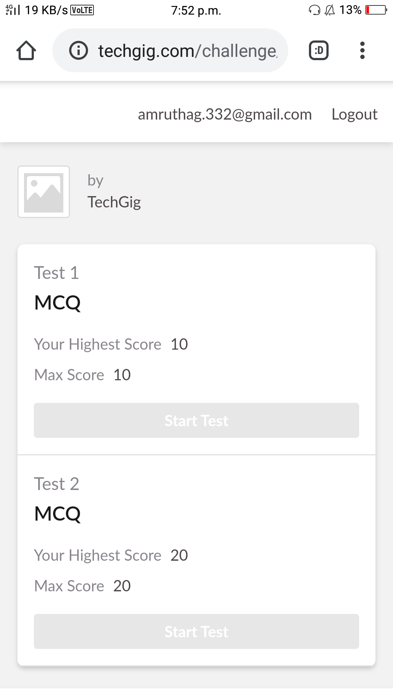

**Online Certification course:**

Name of the course : Robotic process automation

Duration: 3 hours

Certificate provider: Google-Guvi

Today I have successfully completed the robotic process automation certification course.

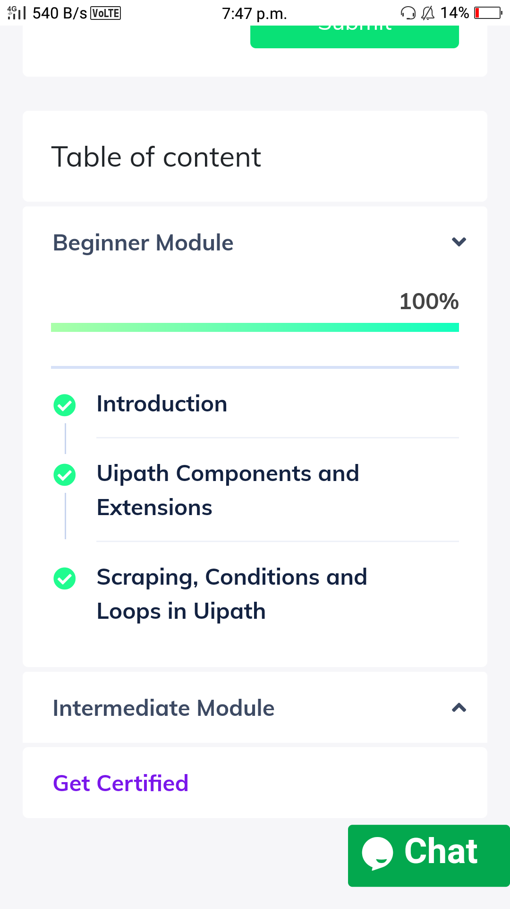

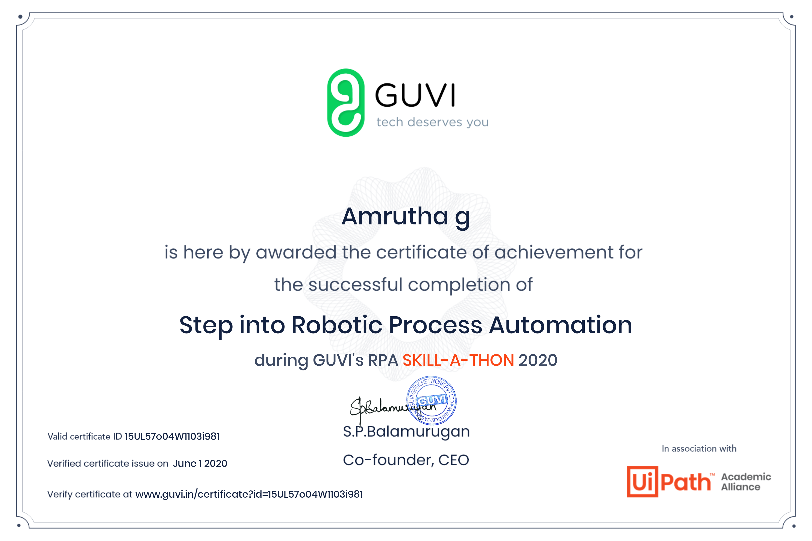

Online Coding summary:

1.Write a java program to calculate distance between points p1 and p2.

2.write a java program to find nPr.

